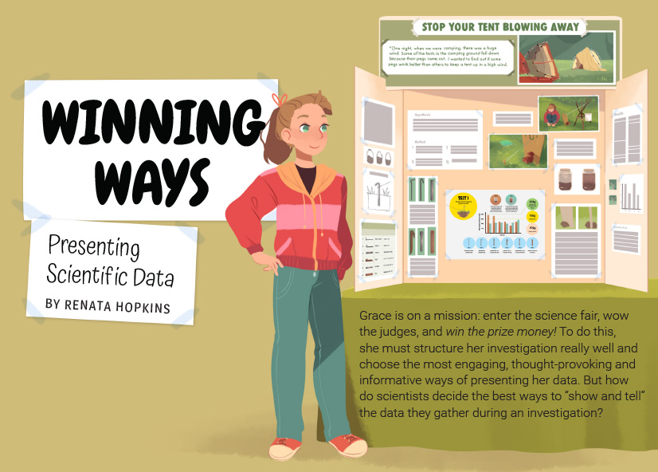
Connected
Level 4
2016

Winning Ways: Presenting Scientific Data
by Renata Hopkins

Overview
This article tells the story of Grace, a year 8 student who has a mission to win a science fair. It is based on the real story of Lauren Kendon, who succeeded in her mission as a consequence of both the design and execution of her experiment and the thoughtful way she communicated her findings. The article focuses on the latter aspect, providing a valuable resource for developing students’ understandings about how to present scientific data.
A Google Slides version of this article is available at www.connected.tki.org.nz.

Curriculum contexts

SCIENCE: Nature of Science: Communicating in science  Level 4 – Begin to use a range of scientific symbols, conventions, and vocabulary. | Key Nature of Science ideas  Scientists:  - use evidence from systematic data collection and analysis to understand the world  - use a range of text forms to help others understand what they did and to allow others to work out how reliable and valid the evidence is  - present findings clearly and accurately so others can understand what they found out.
ENGLISH: Reading  Level 4 – Ideas: Students will show an increasing understanding of ideas within, across, and beyond texts. | Indicators  - Makes meaning of increasingly complex texts by identifying and understanding main and subsidiary ideas and the links between them.  - Makes connections by thinking about underlying ideas within and between texts from a range of contexts.  - Recognises that there may be more than one reading available within a text.  - Makes and supports inferences from texts with increasing independence.
MATHEMATICS and STATISTICS: Statistics: Statistical investigation  Level 4 – Plan and conduct investigations using the statistical enquiry cycle:  - determining appropriate variables and data collection methods  - gathering, sorting, and displaying multivariate category, measurement, and time-series data to detect patterns, variations, relationships, and trends  - comparing distributions visually  - communicating findings, using appropriate displays. | Key mathematics ideas  - Organising data can revel information, patterns, and trends.  - Looking for patterns is an important part of statistical thinking.

The New Zealand Curriculum

Science capability: interpret representations

Capability overview
Scientists represent their ideas in a variety of ways. They might use models, graphs, charts, diagrams, photographs, and written text. A model is a representation of an idea, an object, a process, or a system. Scientists often use models when something is not directly observable. Models enable scientists to work on their ideas, even though they are often using a limited representation of the “thing” itself. It is important students can identify what is the same and what is different about the model and the thing. | It is important for students to think about how data is presented and ask questions such as:  - What does this representation tell us?  - What is left out?  - How does this representation get the message across?  - Why is it presented in this particular way?  This sort of questioning provides a foundation to critically interact with ideas about science in the media and to participate as critical, informed, and responsible citizens in a society where science plays a significant role.

More about the capability

The capability in action
The science capability “Interpret representations” is about students understanding information that is presented as a description or in visual form and recognising the best way to present information.  Scientific representations include diagrams, models, charts, and graphs, as well as written text.  Scientists develop models and diagrams that best represent their theories and explanations.  Scientists  Scientists use:  - representations that can help both the original scientist and others clarify, critique, and evaluate their ideas, research, and theories  - computer and other kinds of modelling to predict what might happen in certain conditions and then test these predictions to see how accurate the model or idea is  - diagrams or models to communicate science ideas  - graphs to present data  - scientific forms of text involving argumentation that use evidence to debate explanations.  Students  Students should have opportunities to:  - learn to interpret a variety of representations, including models, diagrams, graphs, and text  - develop their own representations of scientific ideas, for example, through modelling using concrete materials or using their own bodies in mime and drama  - recognise how the model or representation matches the science idea and how it is different  - consider and critique a range of representations, including scientific texts, newspaper articles about scientific matters, online information about science matters, and scientific representations developed by their peers. | Teachers  Teachers can:  - help students to be more critical consumers of science information by being explicitly critical themselves and modelling useful questions  - support students to evaluate how information is presented, for example, to assess if a graphical representation has been done appropriately or is it misleading  - ask questions such as:  - What do you think this representation tells us?  - What do the (arrows, lines, symbols, etc.) mean? (that is, help your students interpret the features)  - Is anything left out? Do you think anything is missing?  - How does this get the message across?  - Is there anything more you need to know to be able to interpret this representation?  - How does the representation make the science idea clear?  - Which aspects of this representation could mislead the reader?  - Why is it presented in this way?  - Could you suggest a better way to represent it?  - establish a science classroom culture by:  - modelling and encouraging a critical stance  - encouraging students to consider the quality and interpretation of scientific representations  - introducing learning conversations that involve interpreting, critiquing, and developing representations to demonstrate the idea's relevance in everyday life.

More activities to develop the capability

Meeting the literacy challenges

The main literacy demands of this text lie in understanding that the text has at least two purposes: to describe the investigative process Grace carried out as she investigated how much force a tent peg can withstand; and to explain her uses of different types of graphs and tables, including an infographic to represent scientific data. This requires students to integrate and synthesise information from the body text as well as from the diagrams, graphs, tables, and text boxes. | The following strategies will support students to understand, respond to, and think critically about the information and ideas in the text.  You may wish to use shared or guided reading, or a mixture of both, depending on your students’ reading expertise and background knowledge.  After reading the text, support students to explore the activities outlined in the following pages.

INSTRUCTIONAL STRATEGIES

Finding the main ideas  Have the students read the title and first paragraph. ASK QUESTIONS to help them predict the author’s purpose and to start them thinking about how the author seeks to achieve this purpose.  - This article has a very interesting title. “Winning ways: Presenting scientific data.” In five words, the author gives us information about the content of this article. What do you think might be the connection between “winning” and “presenting scientific data”?  - This article begins with a description of Grace’s task. What are some of the language features the author uses for this? Why do you think she uses them?  - Look at the colon in the first sentence. Why has the author used this form of punctuation? What else do you notice about the punctuation in the first paragraph?  - As you read, see if you can identify other types of punctuation the author uses effectively.  The statement that Grace needed to “choose the most engaging, thought-provoking, and informative ways of presenting her data” introduces the idea of selecting appropriate representations. The rest of the article makes it clear that different representations have different purposes. Briefly DISCUSS the sorts of things scientists need to consider when communicating their findings.  - The writer says that Grace needed to “choose the most engaging, thought-provoking, and informative ways of presenting her data.” Is this all she needed to consider?  - Who are the audiences that scientists want to communicate with? Might scientists need to communicate data in different ways to different audiences?  When the students get to the end of page 3, PROMPT them to notice the direct address to the reader, which includes questions to prompt thinking. COMPARE the questions to the rhetorical question on page 2. Both are intended to prompt the reader to think and wonder, but the direct questions do so more explicitly.  - Why do you think the author speaks to us in this way? Let’s try responding to her questions as we read. As we do, let’s think about how they affect us and whether they help us get more out of the text than a straight reading.  After the first reading, have the students DISCUSS some of the techniques the writer used to engage their interest.  - How did the direct questioning affect your reading? Do you think this is a useful technique that you could use yourself? When would you use it? | - “A picture paints a thousand words” is an interesting phrase used in this article. Why do you think the writer used it in an article about scientists and data?  - What interesting examples of punctuation did you find? How did they help you as a reader? Or were they a problem for you?  - Look at the different lengths of the sentences. Why are different length sentences effective? How does the writer construct a longer sentence?  Discuss the different types of tables and graphs on pages 5, 6, and 7. Ask the students to read the explanations for each different kind of graph or table before answering the question at the bottom of page 2.  Draw the students’ attention to the use of idiomatic language and CHECK their understanding, especially if some of your students are English language learners.  - The author uses a lot of idiomatic language, like “blow the judges away”, “spark Grace’s interest”. These are sayings – the judges aren’t really going to be blown away!  - Can you find more examples of idiomatic language? Explain what they mean to a partner.  - Why do you think the author chose to use these expressions?  Dealing with scientific vocabulary  Have the students reread page 3. DISCUSS the term “raw data” and clarify the process that data goes through before it can be viewed as evidence.  - What is “data”? Is it just numbers? Can other kinds of information also be called data?  - What is the difference between “recording”, “analysing”, and “summarising” data? What is the order in which these things happen? Can you present this process as a flowchart?  - Can you think of an example of when we (the class) have gone through this process? How did we represent the data at each point? Why did we make those choices?  Have the students SKIM and SCAN the text to find all of the words that relate to the topic of a statistical investigation. Together, create a mind map with the term “raw data” in the centre and the other terms grouped around it, joined by lines that show the relationships between the concepts.

Meeting the literacy challenges

TEACHER SUPPORT
Scientists use evidence from systematic data collection and analysis to understand the world.

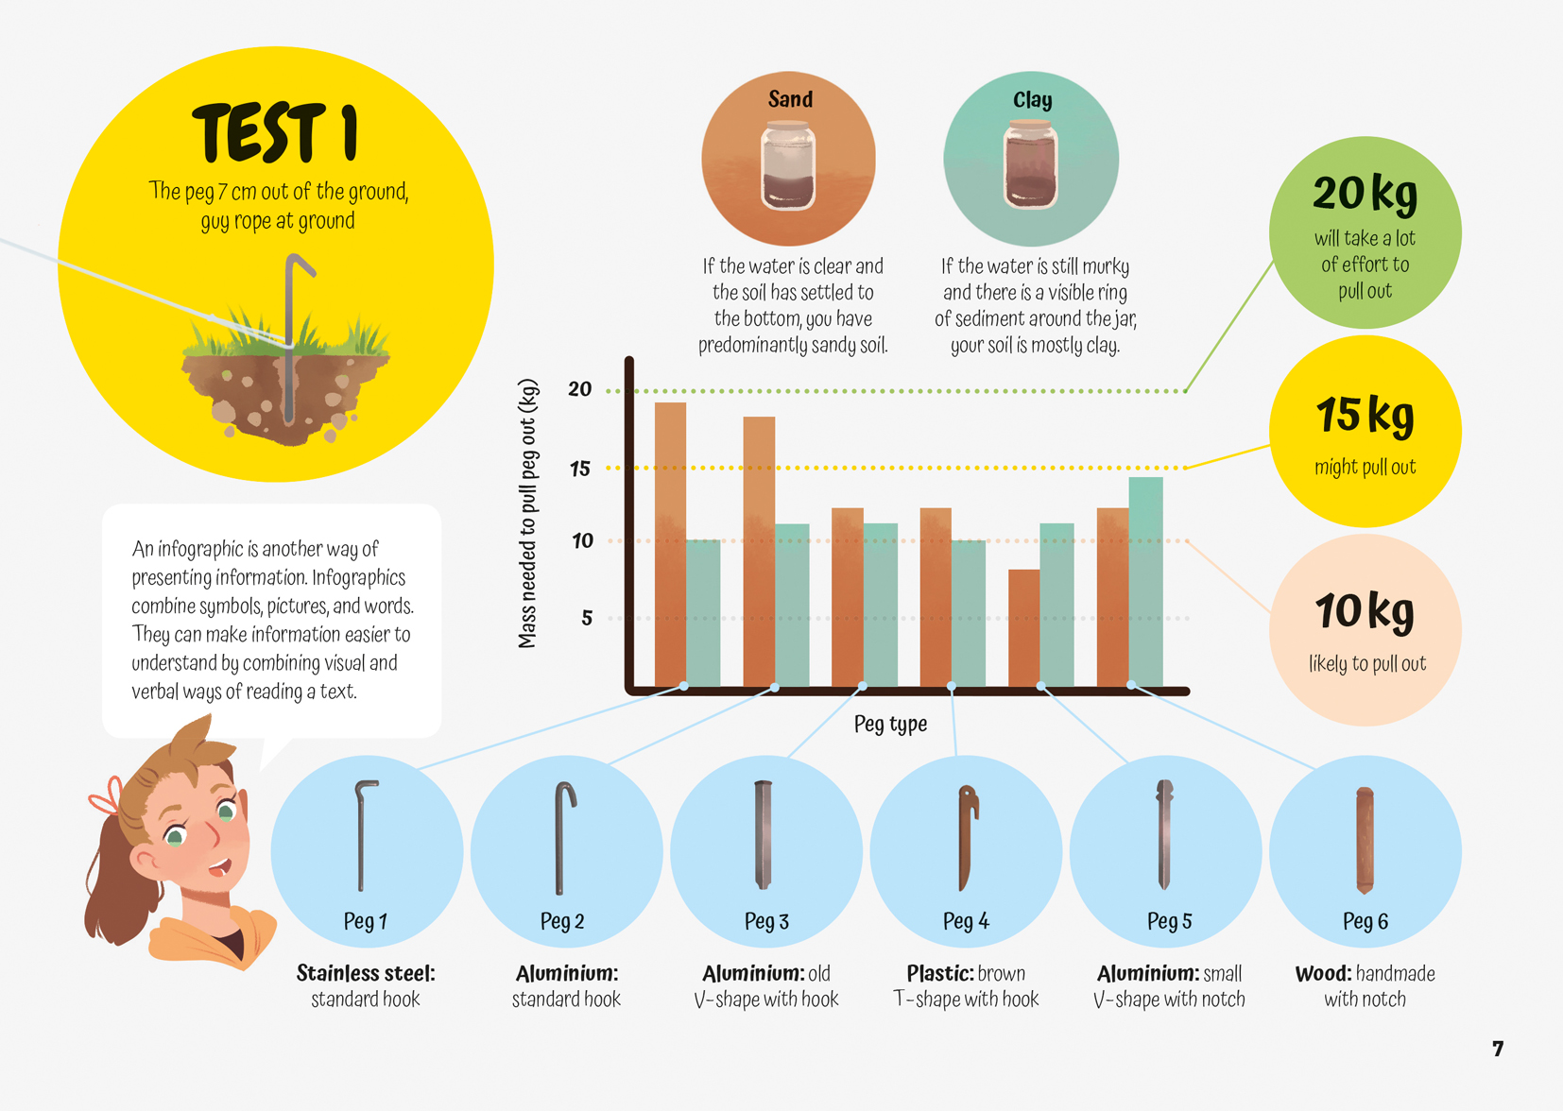
Scientists present findings clearly and accurately so others can understand what they found.

Scientists use a range of text forms to help others understand what they did and to allow others to work out how reliable and valid the evidence is.

Reading standard: by the end of year 8
The Literacy Learning Progressions
Effective Literacy Practice: years 5–8

Learning activities – Exploring the science
The following activities are a guide for supporting students to explore and develop understandings about the science capability “interpret representations”. Some activities focus directly on the science capability. Other activities extend student content knowledge across the learning areas. Adapt these activities to support your students’ learning needs.

Activity 1 – Critiquing data representations
The text incorporates questions to help students make sense of the different methods of representing data. The ideas here are intended to bring their thinking together and connect the concepts in the text to their own knowledge and experience.
Have the students reread the text on page 3 and identify the key criteria for representing data. (The data should be presented clearly, accurately, and informatively.) Have them look closely at the table on page 5 and identify features that they would expect to see in any representation of data (such as a heading, caption, and labels). Have them compare this with the ways data is represented in this text.
Prompt the students to critique the author’s criteria for effective methods of presenting data. Draw out the fact that in communicating scientific information, it is more important that the information is orderly than that it is visually attractive.
- Do the different representations of data all meet the author’s criteria? Why or why not?
- Do they all have all the features you would expect in a data representation? Why or why not?
- Do you agree with the author’s criteria? Why or why not? What would you add, change, or not include?
- If you were to rank the criteria from least to most important, how would you do this? Why?
Have examples of diagrams and tables from a range of sources, including the students’ work in different parts of the curriculum, scientific journals, and media items such as advertisements, posters, or leaflets. Briefly deconstruct several of the examples. Prompt the students to think about the criteria for an effective diagram, relating it to the purpose and intended audience.
- Does this have all the features you would expect in a diagram?
- What is the purpose of this diagram? Who is it for?
- Does this diagram meet the criteria we agreed upon?
- Do we need to adjust our criteria?
Working in pairs or small groups, have the students create posters that:
- summarise what they know about different methods of recording, analysing, or summarising data
- explain the strengths of each of the different representations
- provide an example of each method
- incorporate an explanation of the purpose and effectiveness of their examples.
The students can self- and peer-assess their posters, using the criteria they already know.

Activity 2 – Critiquing scientific writing
This article introduces the idea of scientific writing. Have the students follow a similar process to activity 1, where they:
- identify the criteria for effective scientific writing that are explained in the article
- compare these criteria with a range of examples of scientific writing that have been written for different audiences or purposes (for example, comparing information on a drug that is written for a doctor with information written for the general public).
- write an explanation of how scientific writing is different from or similar to other text types.
Remember that there is a reciprocal relationship between scientific talk and scientific writing. Allow plenty of time for students to talk about their ideas before they begin to write.

Activity 3 – Doing it ourselves
One of the strengths of Grace’s entry was that she didn’t just do one test; she did a series of investigations. To reinforce this message, have the students design a diagram showing the different ways she tested the pegs and what they think each of these tests would tell her about the pegs. Ask questions to focus the students’ attention on how Grace approached her investigation and on the value of the different methods of representing her data.
- Why do you think Grace conducted so many investigations?
- The article mentions that Grace kept a logbook. What do you think a logbook is? How would it have helped her with her project?
- What do you think would be the most appropriate way for Grace to represent the data from each of these investigations?
Following the story, have the students set up their own guidelines for doing an investigation for a science fair. This could be a publicly run science fair or one for the class. There is further information in the resource links that could help them expand on their guidelines and get them thinking about the sort of investigation they would like to carry out. Point out that Grace investigated a problem she had actually experienced and encourage the students to do the same.
Ideally, the students will have carried out activities 1 and 2 before conducting this activity, but if not, they could still reread the article and summarise what it says about the best ways to represent data. This would then provide the criteria for evaluation.

Learning activities – Exploring the science

RESOURCE LINKS

Connected  “The Science of Rongoā”. Connected 3, 2015  Science Learning Hub  http://link.sciencelearn.org.nz/resources/418-the-investigating-in-science-strand  http://link.sciencelearn.org.nz/resources/419-the-communicating-in-science-strand  Other sources  National Library: http://schools.natlib.govt.nz/resources-learning/high-interest-topics/science-projects-and-science-fairs  Science fair project ideas: www.education.com/science-fair/  Science Buddies: Science fair project ideas: www.sciencebuddies.org/science-fair-projects/project_ideas.shtml  Science Online: How science fair projects strengthen “engage with science” capability: http://scienceonline.tki.org.nz/Science-capabilities-for-citizenship/Introducing-five-science-capabilities/Engage-with-science/Science-fairs | BP Educational Service (UK site – you will need to register to access the resources)  Introduction to scientific investigation: http://bpes.bp.com/primary-resources/science/ages-9-to-11/working-scientifically/introduction-to-scientific-investigation/  Introduction to planning an experiment: http://bpes.bp.com/primary-resources/science/ages-9-to-11/working-scientifically/introduction-to-planning-an-experiment/  Introduction to obtaining and presenting evidence: http://bpes.bp.com/primary-resources/science/ages-9-to-11/working-scientifically/introduction-to-obtaining-and-presenting-evidence/  Introduction to considering and evaluating evidence: http://bpes.bp.com/primary-resources/science/ages-9-to-11/working-scientifically/introduction-to-considering-and-evaluating-evidence/  Science writing  Science Writing: A tool for learning science and developing language: www.exploratorium.edu/education/ifi/inquiry-and-eld/educators-guide/science-writing

Learning activities – Exploring the
mathematics and statistics
The following activities are a guide for supporting students to develop capabilities relating to gathering, interpreting, and displaying data, as well as statistical thinking. Adapt the activities to suit the specific needs of your students.

Activity 1 – Bouncing Back  Bouncing Back is a Figure It Out activity in which students carry out a mathematical investigation into the relationship between the height a ball is released and the height of the first bounce. Students then conduct a similar investigation comparing the bounce of a ball before and after it has spent at least twelve hours in a refrigerator. They record their data on a table and then plot it on a graph to analyse and interpret it. | Activity 2 – “The Great Marble Challenge”  In “The Great Marble Challenge”, students design and test a ramp that is intended to get a marble to stop at a set distance. The text includes graphs and data tables, and the teacher support materials suggest ways to extend student learning on interpreting and displaying data.

RESOURCE LINKS

Connected  “The Great Marble Challenge” Connected 4, 2014 https://docs.google.com/presentation/d/1aixO9dLX6rBqa811XPMZOuAeCCjPzKYxWw-1rjP3h8Y/present?slide=id.p  Assessment Resource Banks  Tables and graphs: https://arbs.nzcer.org.nz/tables-and-graphs | Figure It Out  Bouncing Back: Technology in Practice, Levels 3+–4+, pages 12–13 https://nzmaths.co.nz/sites/default/files/BouncingBack_0.pdf

Learning activities – Link to technology
The following activities are a guide for supporting students to explore and develop understandings about technological development and outcomes.

The students could investigate the kinds of shelters used in different environments.
- What kinds of shelters do mountain climbers use? Or desert nomads?
- What kind of shelters might be used on the moon?
Students could first examine the kinds of shelters used in extreme parts of the world, such as the Arctic or Antarctic, the Sahara desert, Siberia, or when climbing Everest. They could then design and model a range of portable shelters that will withstand extreme weather events. Alternatively, their focus could be on the design of a shelter that could be used in an emergency.

RESOURCE LINKS

Teach Engineering  The need for shelter: www.teachengineering.org/lessons/view/csm_lesson3_shelter_tg  Space shelter: www.teachengineering.org/activities/view/space_shelter | Figure It Out  Emergency shelters: Technology in Practice, Level 3+–4+, pages 14–15 https://nzmaths.co.nz/resource/emergency-shelters

